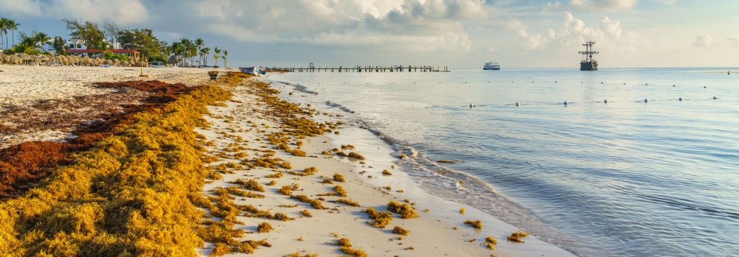
Cotton Recycling & Sargassum Paper Research

Dr. Renate C.-Z.-Quehenberger with Dr. Sherief Shokry

RCZQ is collaborating with Dr. Sherief Shokry who is teaching at the Art Faculty of the Egyptian Russian University (ERU) in Cairo and works in his laboratory in Alexandria (EG).

Dr. Shokry is widely recognized for his inventive capacity in the development of new machines such as printing presses and silk-screen dryers (.f.e. for the ERU in Cairo) and pottery, as well as a machine for cutting textiles into tiny flakes to make paper from waste textiles.

Most recently he started his first successful experiments on producing paper materials from cotton flakes and seaweed. Alternative eco-friendly methods for producing paper are urgently needed since 2.2 kilos of wood are needed to produce 1 kilo of paper whereas tons of seaweed are washed ashore in the Caribbean and worldwide waiting for sustainable usage. In Egypt seaweed can be found on the shores of the Mediterranean Sea, West of Alexandria.

GSIS aims to support Dr. Shokry’s material experiments and by assisting in the search for partners for the industrial production of this sustainable and eco-friendly sargassum paper.

Funding will be used for further research and experiments for producing seaweed pulp for paper and packaging materials. This sustainability project aims to showcase a product that is freely provided by nature and can be given back to nature in a natural circle due to the use of natural non-non-toxic ingredients.

GSIS-donations with code: SW-paper

